1. How we can stop modifying the object once object is created.  
   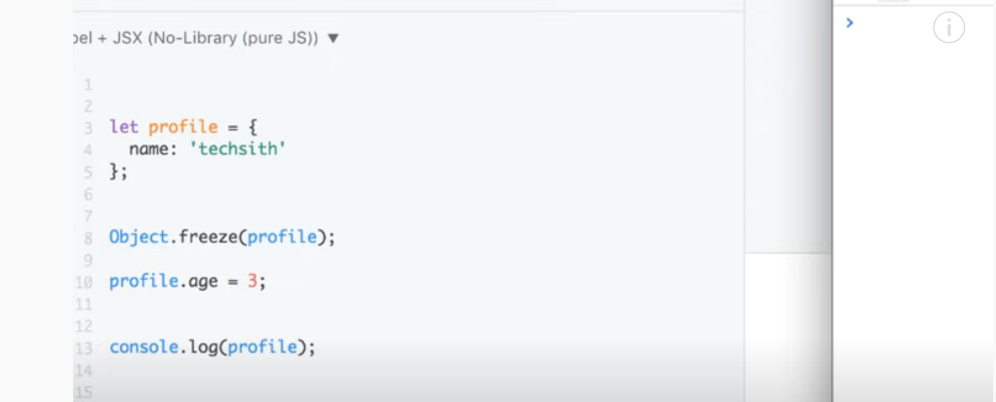
2. We can modify the property but we can not add new property.
3. 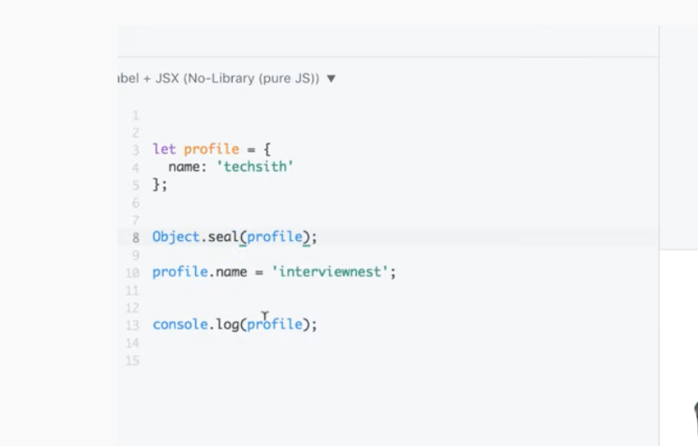
4. How we configure object. Some property will be modify but some can not   
   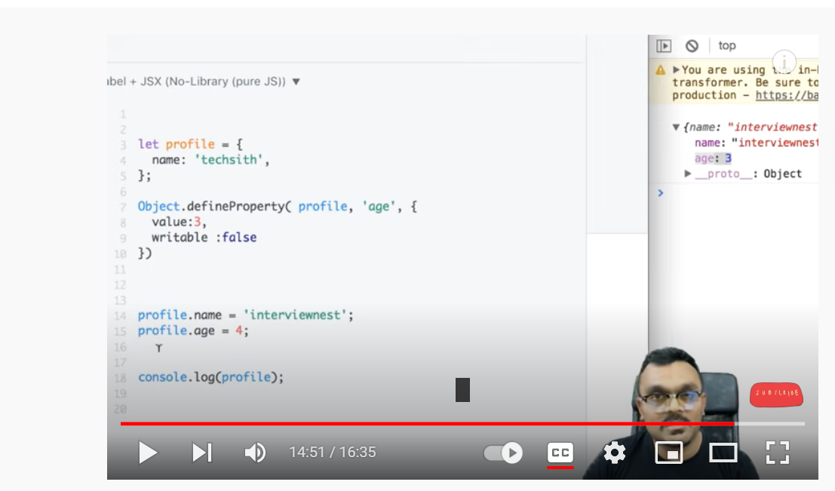
5. console.log(Math.max(...[1,2,3])) //3
6. console.log(Math.max()) // -Infinity